Unit 1 KK音標學習單
商201 座號______ 姓名_________

母音 | 範例 |  | 子音 | 範例
[i] | see [si] ; he [hi] |  | [p] | pen [pZn] ; help [hZlp]
[I] | it [It] ; him [hIm] |  | [b] | be [bi] ; tub [tQb]
[e] | name [nem] ; say [se] |  | [t] | tea [ti] ; out [aJt]
[Z] | ten [tZn] ; head [hZd] |  | [d] | day [de] ; sad [sAd]
[A] | cat [kAt] ; and [And] |  | [k] | key [ki] ; back [bAk]
[B] | hot [hBt] ; want [wBnt] |  | [g] | game [gem] ; big [bIg]
[C] | dog [dCg] ; law [lC] |  | [f] | fire [faIr] ; knife [naIf]
[o] | go [go] ; low [lo] |  | [v] | vote [vot] ; give [gIv]
[J] | look [lJk] ; put [pJt] |  | [W] | thing [WIN] ; both [boW]
[u] | food [fud] ; do [du] |  | [T] | they [Te] ; father [`fBTL]
[3] | girl [g3l] ; earn [3n] |  | [s] | sit [sIt] ; bus [bQz]
[L] | teacher [`ti+L] ; better [`bZtL] |  | [z] | zoo [zu] ; does [dQz]
[E] | of [Ev] ; about [E`baJt] |  | [F] | she [Fi] ; dish [dIF]
[Q] | cup [kQp] ; above [E`bQv] |  | [V] | Asia [`eVE] ; decision [dI`sIVEn]
[aI] | five [faIv] ; like [laIk] |  | [h] | high [haI] ; home [hom]
[aJ] | how [haJ] ; house [haJs] |  | [+] | cheap [+Ip] ; rich [rI+]
[CI] | boy [bCI] ; join [0CIn] |  | [0] | joke [0ok] ; age [e0]
 |  |  | [m] | make [mek] ; him [hIm]
 |  |  | [n] | now [naJ] ; soon [sun]
 |  |  | [n. ] | cousin [`kQzn. ] ; season [`sizn. ]
 |  |  | [N] | song [sCN] ; king [kIN]
 |  |  | [I] | low [lo] ; tall [tCl]
 |  |  | [>] | candle [`kAnd>]
 |  |  | [w] | way [we] ; wise [waIz]
 |  |  | [hw] | why [hwaI] ; what [hwBt]
 |  |  | [j] | you [ju] ; yes [jZs]
 |  |  | [r] | red [rZd] ; fear [fIr]

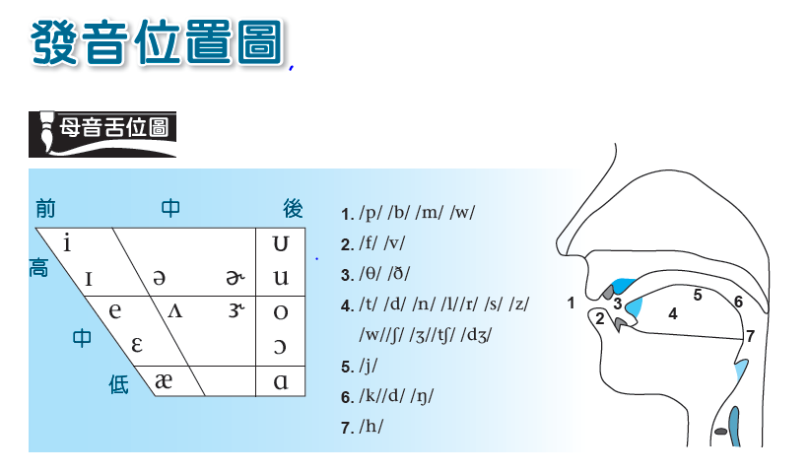

發音練習
請選出單字畫底線部分發音不相同
( ) 1. (A) eat (B) pick (C) teach (D) speak
( ) 2. (A) waste (B) head (C) dead (D) ready
( ) 3. (A) tooth (B) fool (C) good (D) cool
( ) 4. (A) cloth (B) soft (C) across (D) note
( ) 5. (A) camp (B) father (C) add (D) ask
( ) 6. (A) many (B) have (C) last (D) laugh
( ) 7. (A) blood (B) enough (C) touch (D) ready
( ) 8. (A) noise (B) smile (C) join (D) choice
( ) 9. (A) thank (B) thick (C) through (D) there
( ) 10. (A) same (B) star (C) please (D) past
( ) 11. (A) shirt (B) usual (C) wash (D) dish
( ) 12. (A) rich (B) age (C) badge (D) orange

